**T.W. Josey Question and Answer Sheet**

**Cannot login in: Have you tried the following:   
1. Login in through your RCSS Launchpad**

**2. Go to infinite campus- you will find your schedule**

**3. If you have classes in the Canvas Platform your content and core classes will be there. Look for RCBOE Canvas (Red Icon) See below. Then, look for your (students) dashboard. You should classes that you are enrolled in. Then, scroll down the left side of your computer. Look for modules.**

**4.If you have classes in Edgenuity, look for the Edgenuity Platform, not Credit Bearing. Start your classes.**

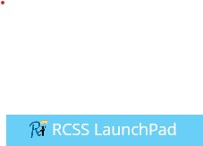

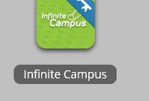

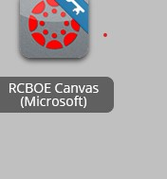



**If that does not work, please contact the following individuals:**

1. School support email addresses:

**Dr. Litfin (Media Specialist):** [**LitfinAm@boe.richmond.k12.ga.us**](mailto:LitfinAm@boe.richmond.k12.ga.us) **Miss Wright (Instructional Coach): WrighFr@boe.richmond.k12.ga.us**